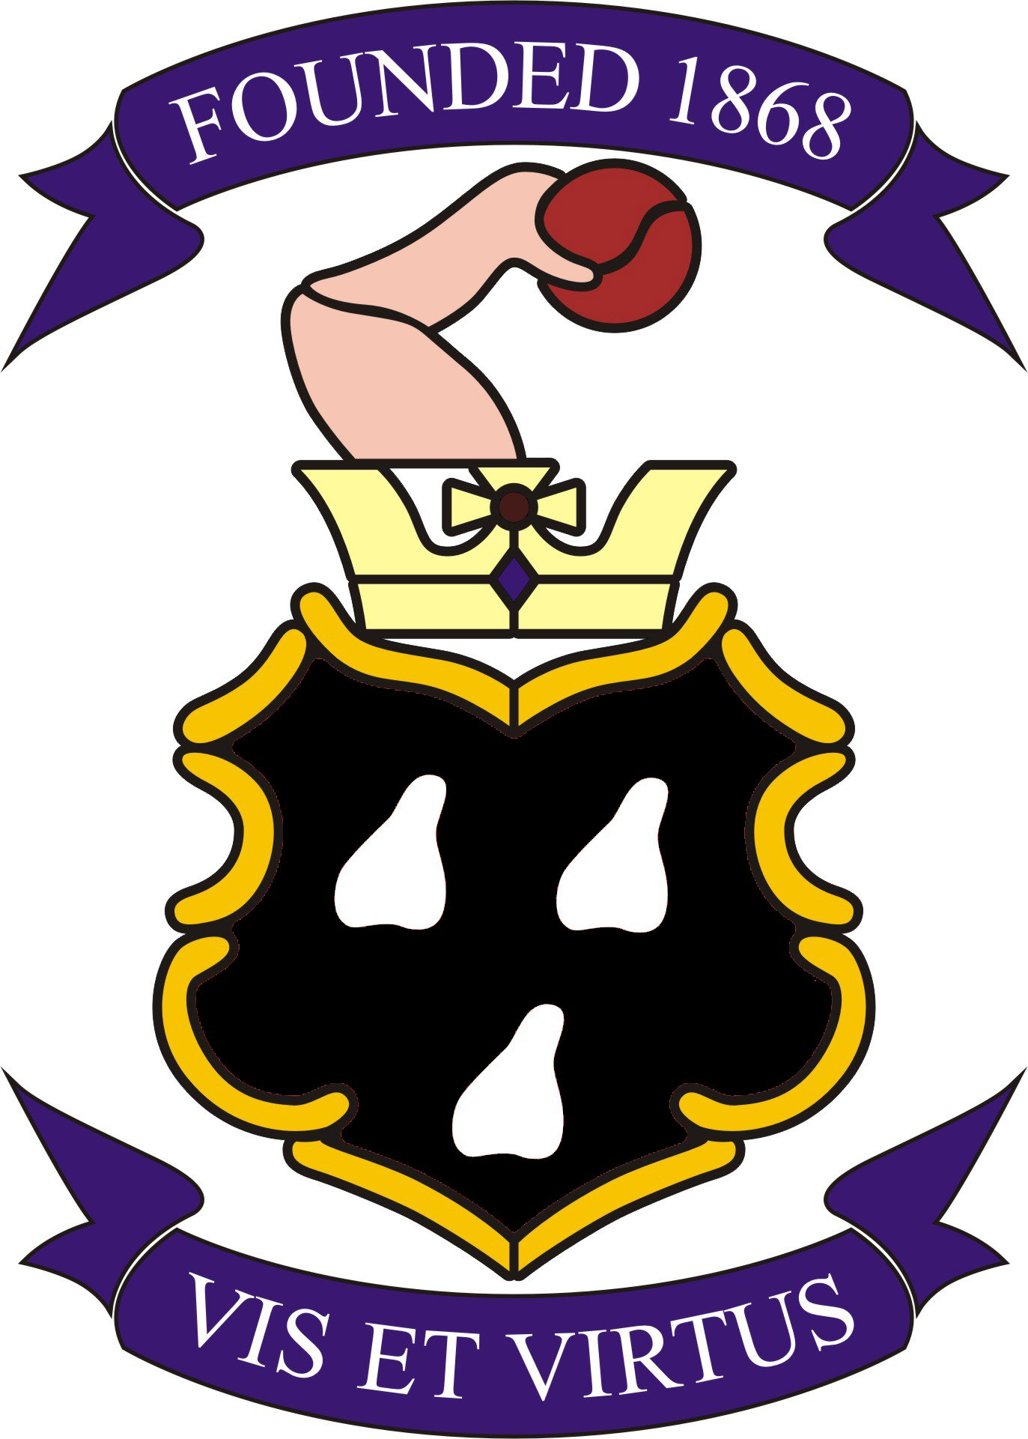

KINGS HEATH CRICKET & SPORTS CLUB
CLUB RULES AND BYE LAWS

1. Under the terms of the Companies House registration, the Club is classified as a Private Company Limited by Guarantee without Share Capital. The Club is a private members club providing a variety of sporting activities and social events for the community at large. The current sports available for members to participate in are Bowls, Cricket, Hockey, Snooker, Squash, Table Tennis, Tennis and Junior Football.

2. Subscriptions are due on the 1st January each year. Renewal notices are sent out in advance of that date. These must be paid by the 31st January to receive a discount when available. Social membership is on a pro rata basis.

3. All members and their guests (for which members are responsible) must at all times behave in:

i. A socially acceptable manner
ii. A sensible and orderly way
iii. A way not to upset other members and staff

Please note sports bags and equipment must be stored in a tidy manner in the Sports Bar preferably on the racks provided, and are not allowed in the lounge.

4. The Club will normally be open to members between the hours of 16:00 to 12.00 midnight, Monday – Friday, excluding Tuesdays where we are open from midday. Weekend hours are midday until midnight on Saturday, then midday until 11pm Sunday. Members are requested to have left the premises by the above times. The main exceptions to the above are Christmas Day, Boxing Day and New Year’s Eve when opening times may vary.

Meals and bar snacks are available:
Bar Kitchen
Monday 16:00-22:30 Closed
Tuesday 12:00-23:30 Closed
Wednesday 16:00-23:30 18:00-21:00
Thursday 16:00-23:30 18:00-21:00
Friday 16:00-23:30 18:00-21:00
Saturday 12:00-23:30 12:00-21:00
Sunday 12:00-22:30 12:00-16:00

Should there be a reason to vary the above times, a notice will be displayed in the Club as soon as possible prior to the change.

Only drinks and food purchased on the premises may be consumed on the premises.

Important: You are asked to leave the Club quietly to respect our neighbours and to conform to our licence conditions.

5. Members may sign in two guests at a time to use the social facilities. Social guests are restricted to no more than ten visits in any twelve month period. The Visitors Book is in the bar and it is the members’ responsibility to ensure all guests are signed in when entering the Club, for which there is a charge. Temporary short-term membership may be available after a written request and acceptance is made to the Membership Secretary.

In the case of Sports members with full membership of any section, they may sign in one guest to play that sport, at any one time. Sports guests are restricted to no more than five visits in any twelve month period. This will include the use of our social facilities.

There is a fee for junior players (up to eighteen years) and a fee for players over eighteen years. It is the responsibility of the player or the member to ensure that this fee is paid.

Coaching fees are agreed between the Directors and the Sections.

Only full members of a section may represent Kings Heath Cricket and Sports Club Ltd., in any event, and only for the section of which they are a member.
The captain of any such competition will be responsible for ensuring that this is adhered to.

6. Members of visiting teams are automatically considered as temporary members on the date of their game.

Members under 18 both sporting and social do not have voting rights at the A.G.M. or the right to sign in guests.

7. The Rules in relation to snooker playing members are displayed beside the snooker tables.

8. Off sale of beers, wines and spirits are permitted.

9. Members are requested to maintain a reasonable standard of dress otherwise entry may be refused.

10. The Club accepts no liability for loss or damage to personal belongings including vehicles parked on the Club grounds.

11. Dogs are not permitted on the Field at any time.

The playing of unauthorised sport is not permitted anywhere on the grounds. or skateboards is also not permitted.

12. Members, their friends and families are welcome to use the Pavilion Bar facilities when it is open. The bar is not subject to the normal visitors rules.

13. Children must be supervised at all times.

Children under 12 years of age must leave the Sports Bar by 10.00 p.m. and from the lounge by 9.00 p.m. on any evening.

Children over 12 years of age may stay in the Club’s Sports Bar until closing time but must be under the full control of an adult at all times.

Junior members are not permitted to use the Club premises outside of Section Activities unless accompanied by a full member.

14. As far as possible coats should be hung on the hooks provided.

15. No Credit will be given, however monies can be put onto membership cards

16. Complaints of a minor nature should be directed to the Club Manager. Complaints of a more serious nature should be made in writing to the Directors.

17. Membership cards should be carried and available for inspection at any time. Your membership card enables you to obtain a discounted member’s price at the bar.

Membership checks will be carried out by a member of staff, a director or any other person at the request of the Directors or Club Manager.

18. A Director, the Club Manager or their appointed deputy is entitled to exclude a member or their guest from the Club if they find that person’s behaviour unacceptable. Such behaviour will be discussed at the next Directors’ Meeting.

Contact Detail
Phone: 0121 444 1913
Email: the cricketclub1@gmail.com

09.05.23

